# **Week 1 Journal – System Planning & Distribution Selection**

**Module:** Operating Systems  
**Assessment:** Week 1 – Phase 1: System Planning and Distribution Selection

1. **System Architecture Diagram**

**Notes:**  
I used my laptop as the host and set up two virtual machines inside VirtualBox. One is the **Ubuntu Server,** and the other is **Linux Mint**. I added both NAT (so they can use the internet) and Host-Only (so they can connect to each other). Each one got its own IP address 192.168.56.101 for Ubuntu and 192.168.56.102 for Mint. I tested both with ping and they worked fine.

1. **Distribution Selection Justification**

Chosen Server Distro: Ubuntu Server 24.04.3 LTS  
Alternatives Considered**:** Debian 12, Rocky Linux 9

Comparison:

* Ubuntu Server 24.04.3 LTS**:** Beginner-friendly, lots of documentation, frequent updates, easy networking setup.
* Debian 12: Very stable but older packages.
* Rocky Linux 9: Enterprise-grade stability but fewer desktop support tools.

Decision:  
I chose Ubuntu Server 24.04.3 LTS because it’s stable, modern, and supported by a large community. It works well on my laptop, has simple commands, and fits the learning goals of the Operating Systems module.

1. **Workstation Configuration Decision**

Chosen Workstation: Linux Mint 22.2 “Zara” (Cinnamon)  
Reasons:

* User-friendly interface and very similar to Ubuntu (same base).
* Easier to take screenshots and access files.
* Perfect for practicing both GUI and terminal commands.
* Stable and lightweight enough to run smoothly in VirtualBox.

1. **Network Configuration**

VirtualBox Settings:

* Adapter 1: NAT (Internet)
* Adapter 2: Host-Only Adapter → VirtualBox Host-Only Ethernet Adapter (192.168.56.1)

IP Addresses:

* The Ubuntu Server is configured with a Host-Only adapter and assigned the IP address 192.168.56.101. It serves as the main server in the setup.
* The Linux Mint virtual machine also uses a Host-Only adapter, with the IP address 192.168.56.102, functioning as a workstation.

Connectivity Tests:

From Server → Workstation: ping 192.168.56.102

From Workstation → Server: ping 192.168.56.101

1. **CLI Evidence – System Specifications**

Ubuntu Server (192.168.56.101)

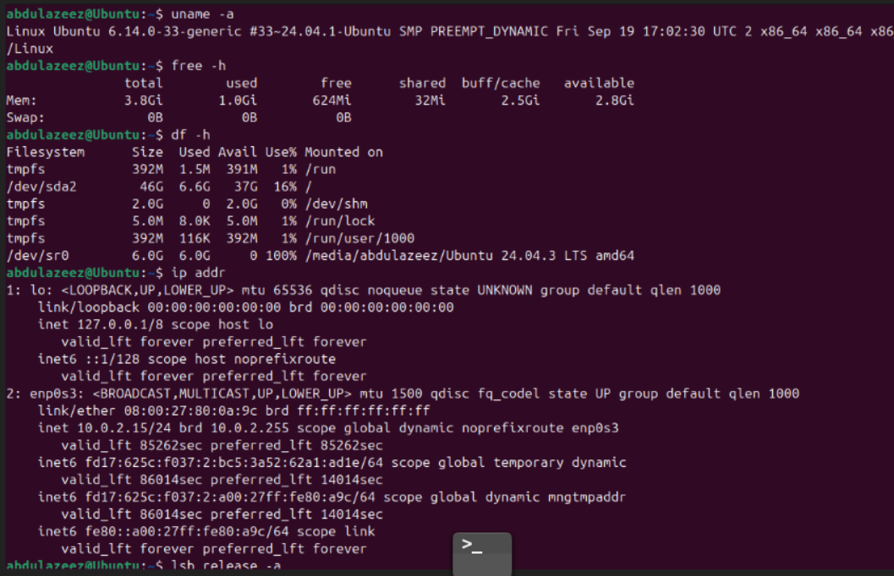

uname -a

Linux Ubuntu 6.14.0-33-generic #33~24.04.1-Ubuntu SMP PREEMPT_DYNAMIC Fri Sep 19 17:02:30 UTC 2024 x86_64 x86_64 x86_64 GNU/Linux

free -h

Mem: 3.8Gi used: 1.0Gi free: 624Mi swap: 0B

df -h

/dev/sda2 46G total, 6.6G used, 37G free (16%)

ip addr

inet 192.168.56.101/24 scope global dynamic enp0s3

lsb_release -a

Distributor ID: Ubuntu

Description: Ubuntu 24.04.3 LTS

Release: 24.04

Codename: noble

**Linux Mint Workstation (192.168.56.102)**

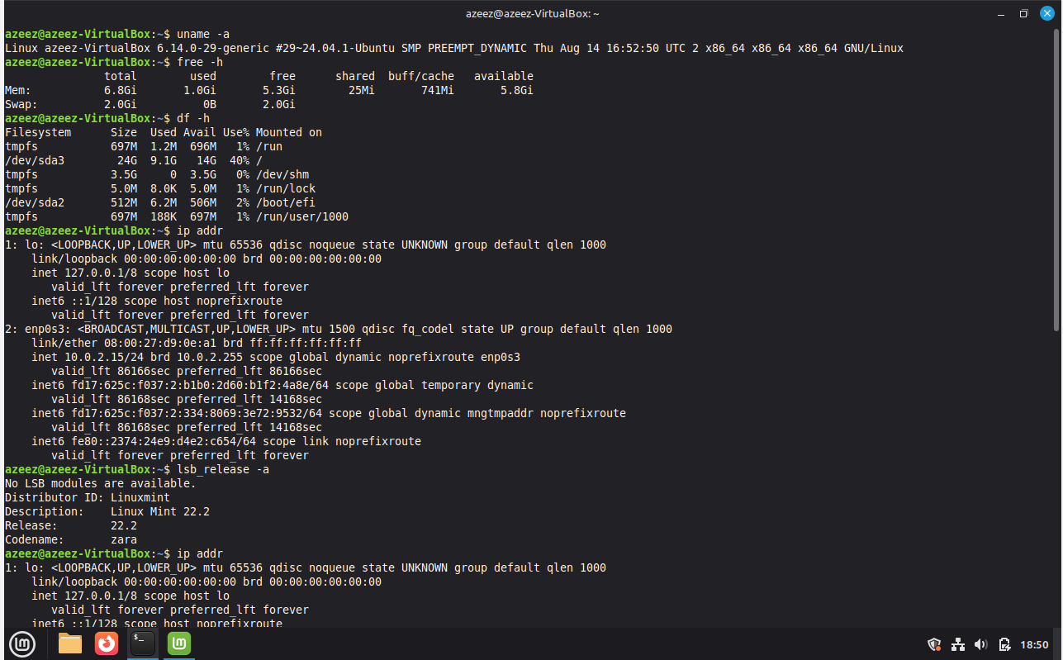

uname -a

Linux azeez@VirtualBox 6.14.0-29-generic #29~24.04.1-Ubuntu SMP PREEMPT_DYNAMIC Thu Aug 14 16:52:50 UTC 2024 x86_64 x86_64 x86_64 GNU/Linux

free -h

Mem: 8.6Gi used: 1.5Gi free: 3.5Gi swap: 2.0Gi

df -h

/dev/sda3 24G total, 9.1G used, 14G free (40%)

ip addr

inet 192.168.56.102/24 scope global dynamic enp0s3

lsb_release -a

Distributor ID: LinuxMint

Description: Linux Mint 22.2

Release: 22.2

Codename: zara